**PRACTICAL 2 part 2**

**AIM:.**

**Creale a Web Page of your Institute which contains:**

**Description of Branch, Description of Courses, Department, Faculties using HTML and CSS Tags**

**DESCRIPTION:**

<SVG> TAG🡪 It is used to embedd a svg image via link.

<BR> TAG🡪 it is used for line break in a web page.

**Output:**

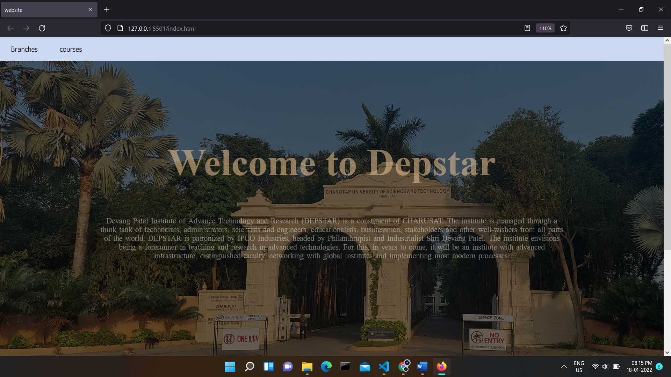

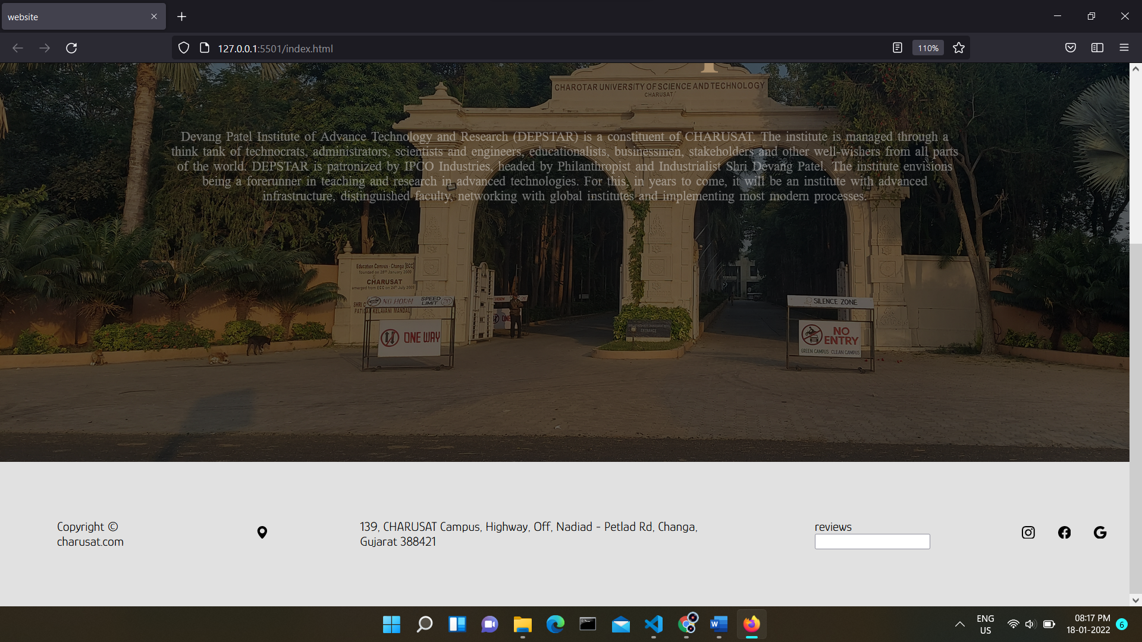

Hover effect:

Normal



Hovered

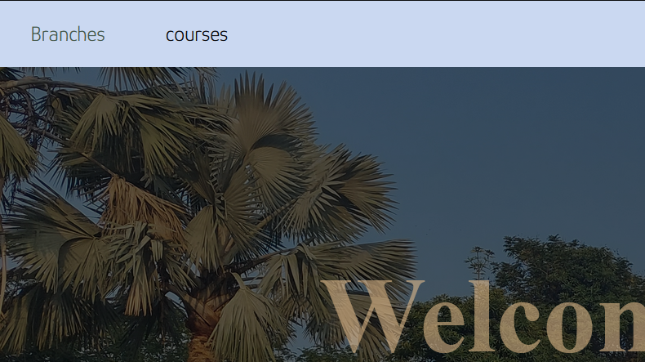

Branches section:

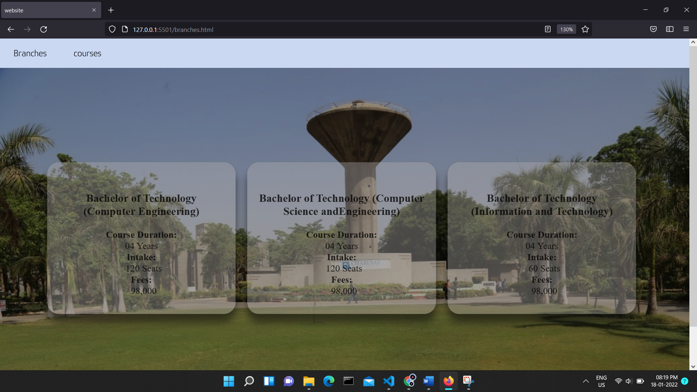

Courses section:

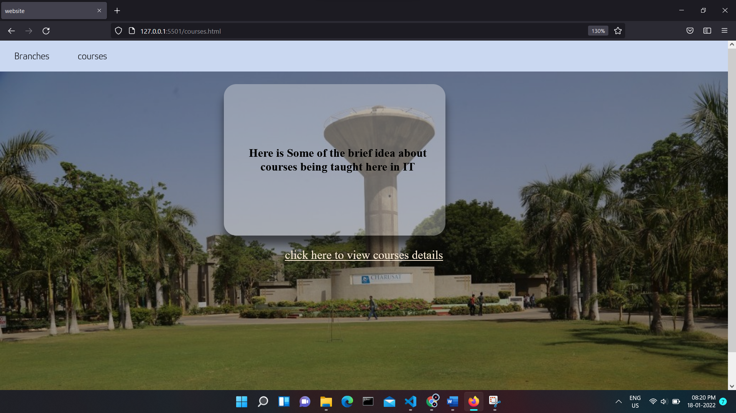

After clicking to the link in the above page says ”click here to view courses details” redirects to another html file basically which is as showed below

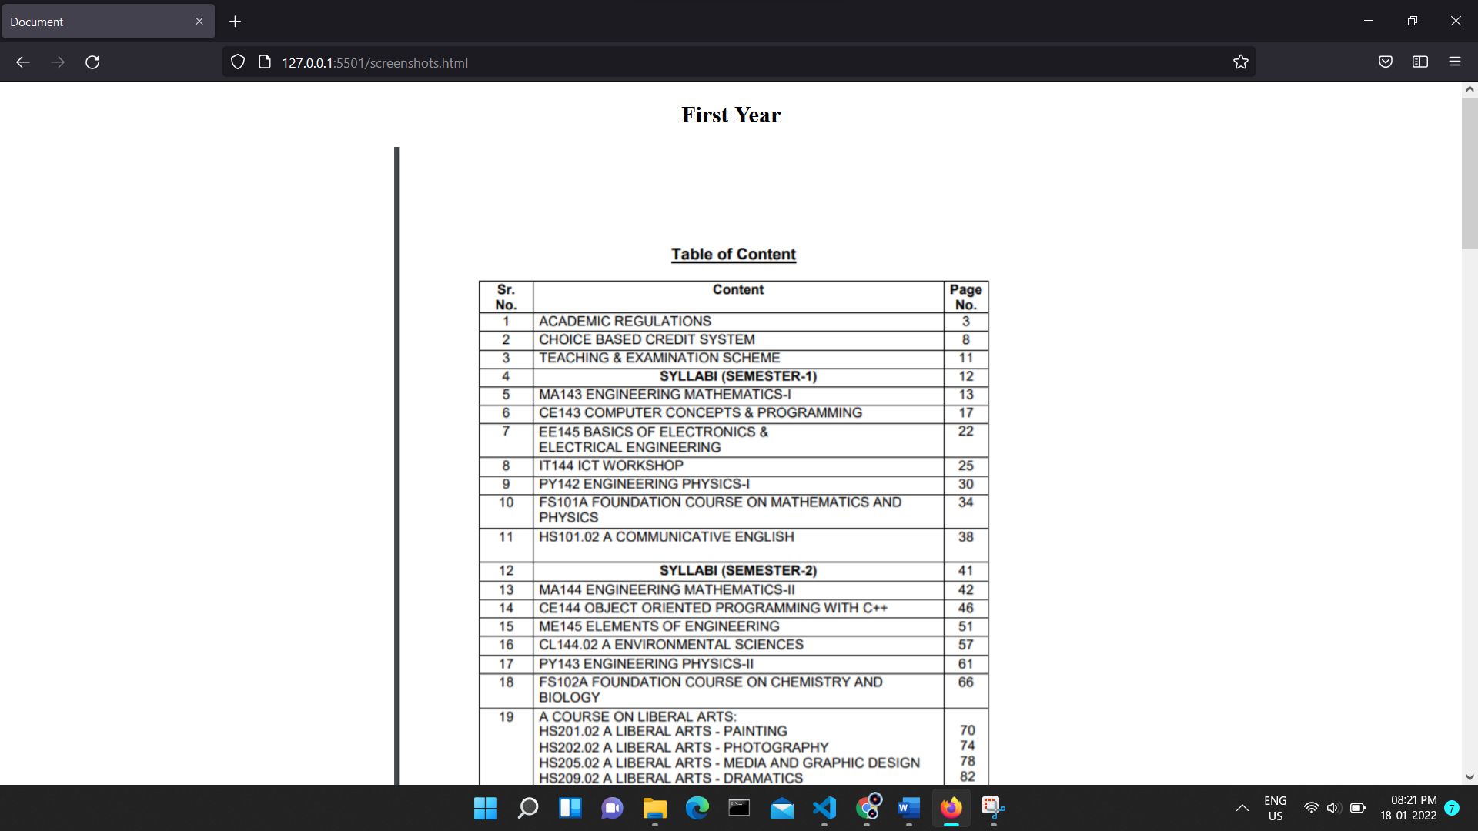

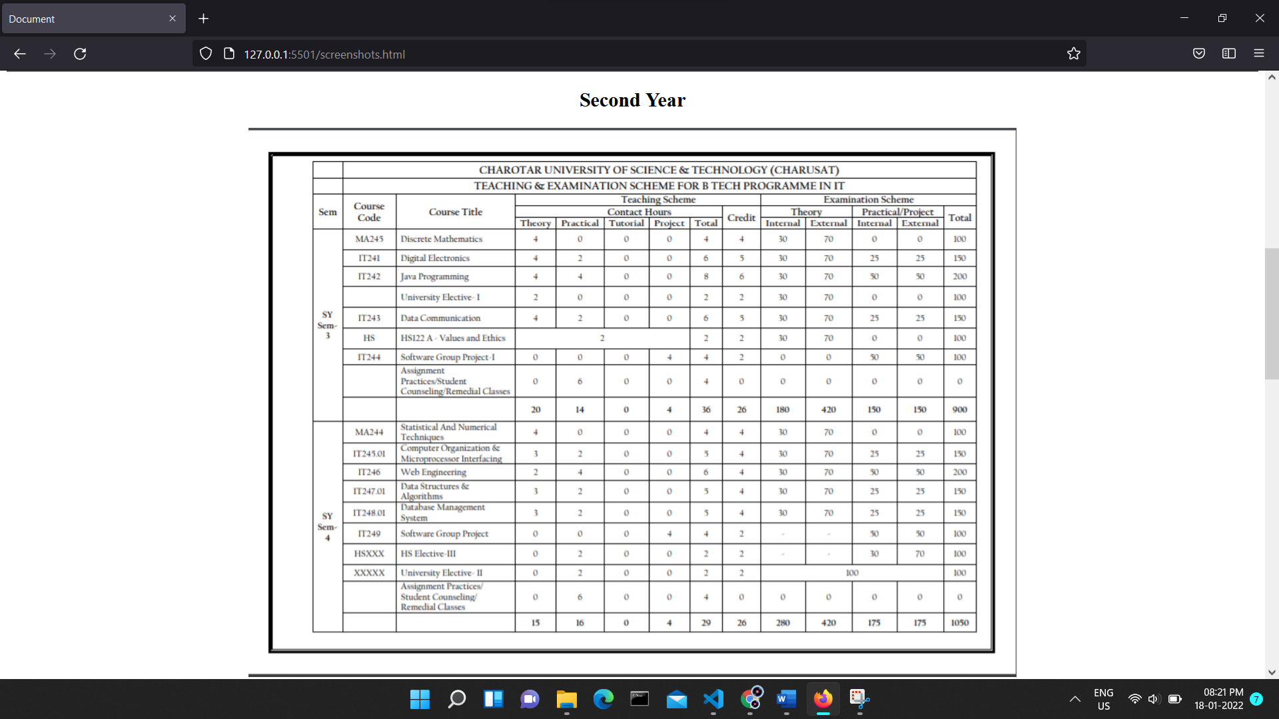

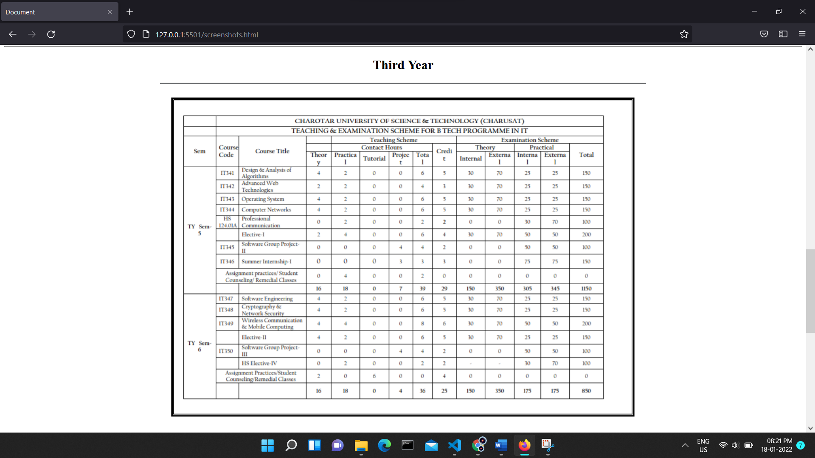

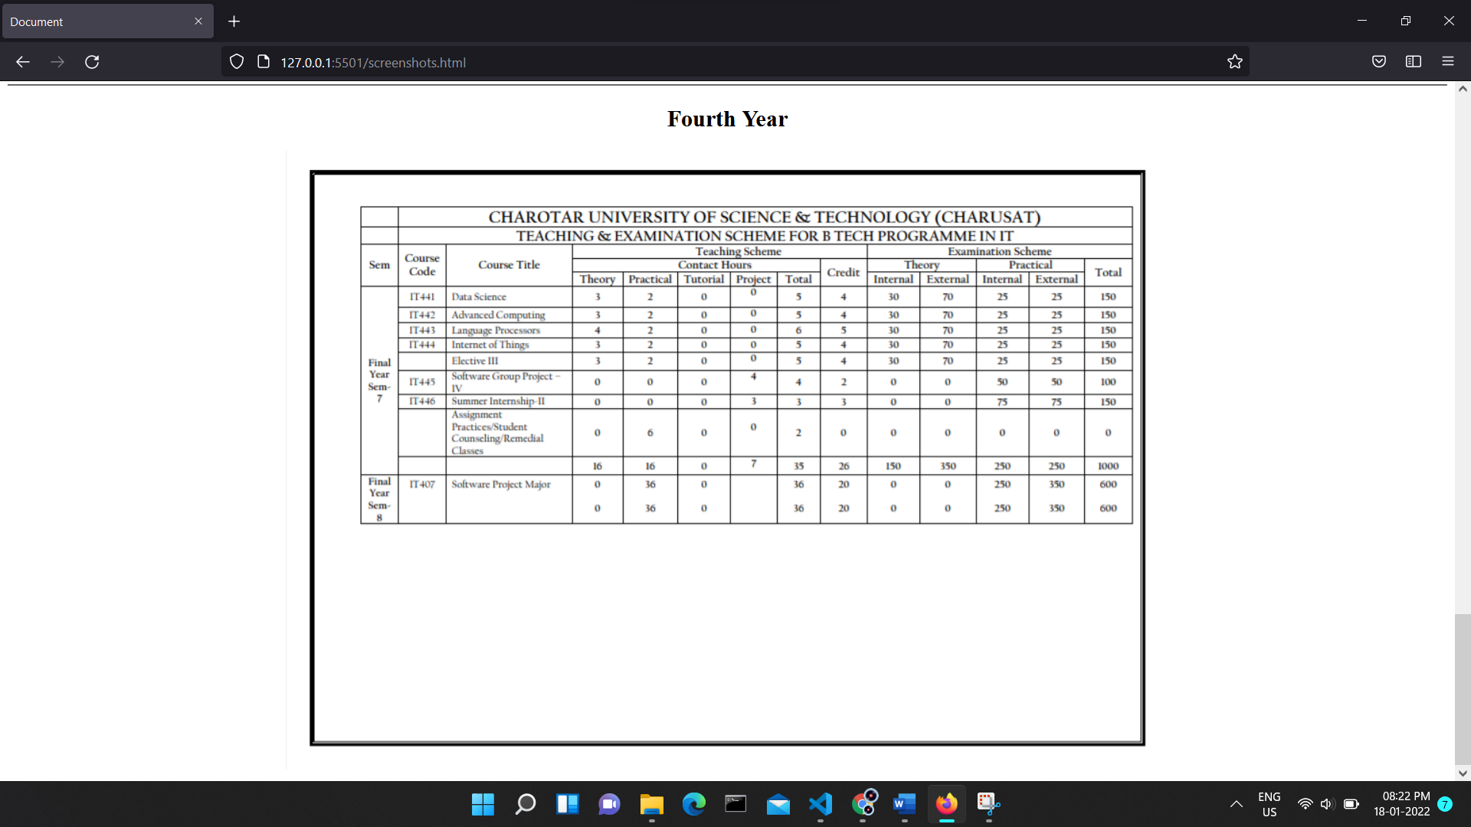

**Note: also it is given in the question that to display faculties details but am not able to find the data regarding it on any sources so not included in this practical file :)**

**CONCLUSION:** here we have made some of the web pages using html and css.